1. Introduction
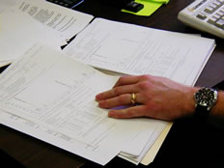

In this case study you will analyze a series of crime scene photographs. You will then develop a plan for collecting and testing the evidence.

2. Case Establishment
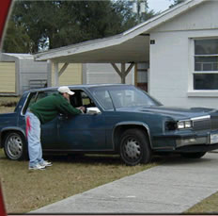
Several weeks of surveillance photography suggested that the suspect was heavily involved in drug dealing. After documenting frequent brief visits to his house by several known drug users officers executed a successful raid on the suspect’s home. A number of items were discovered, seized and subsequently submitted as evidence.
- Surveillance
- Documented Visitation
- Successful Raid
- Seizure of Evidence

3. Crime Scene Evidence
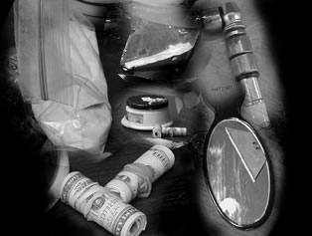
The following crime scene photographs strongly indicate that the occupants of the house were involved in drug use and trafficking. A search of the house revealed several items indicative of drug use and supply. In the kitchen a set of kitchen scales were present, covered with a dusting of white powder. On the table beside them were two rolls of $20 dollar bills, a mirror contaminated with a white powder-like substance, related drug paraphernalia and a Ziploc bag containing white powder. A bag of green herbal material was found in the freezer.
- Coated Kitchen Scales
- $20.00 Bills
- Coated Mirror
- Bag of White Powder
- Bag of Herbal Material
- 4. Crime Scene Photo # 1
- 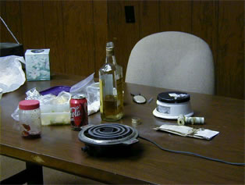
- Photograph 1. Kitchen table in the suspects home. Items present include, kitchen scales, liquor bottle, large quantities of US currency and drug paraphernalia.

5. Crime Scene Photo # 2
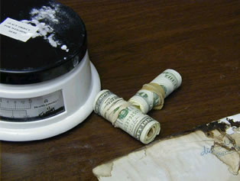
Photograph 2. Close up of soiled kitchen scales and rolls of US currency.

6. Crime Scene Photo # 3
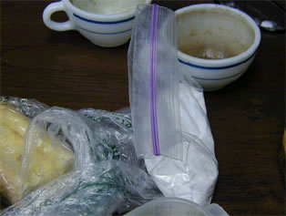
Photograph 3. Bag of white powder.

7. Crime Scene Photo # 4
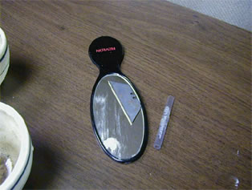
Photograph 4. Mirror and drug paraphernalia

8. Crime Scene Photo # 5
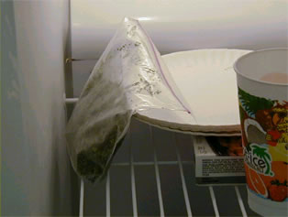
Photograph 5. Bag of herbal material found in freezer

9. Crime Scene Photo # 6
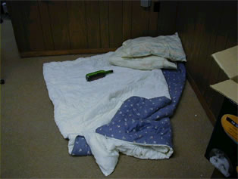
A pile of bedding and liquor bottle were lying in a corner of the kitchen. Officers uncovered a number of rock-like items and what looked like a crack-pipe hidden amongst the covers.
Photograph 6. Bedding and liquor bottle on kitchen floor
- Pile of Bedding
- Liquor Bottle
- Possible "Crack Pipe"

10. Crime Scene Photo # 7
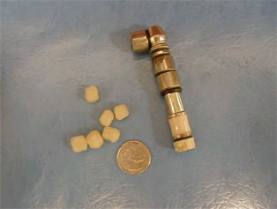
Photograph 7. Unknown substance and drug paraphernalia found in bed

11. Crime Scene Photo # 8
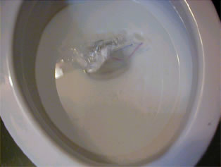
A partially flushed bag of white powder was found floating in the toilet, the bag was open and water had seeped into the bag wetting the powder. Another bag of white powder sealed and dry was found taped to the inside of the cistern.
Photograph 8. Bag of white substance in toilet
- Bag of White Substance in Toilet

12. Crime Scene Photo # 9
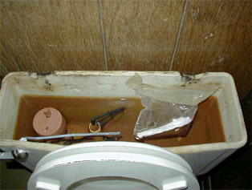
Photograph 9. Bag of white powder in cistern

13. Conclusion - Assignment
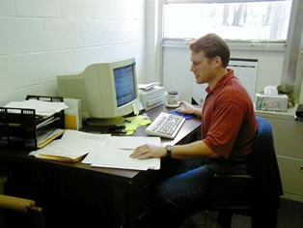
From the narrative and the photographs presented, and using any information presented in module 2. List the possible samples that you would test in the chemistry lab and your rationale for doing so. Outline the preliminary tests that would be conducted on each sample and note any special handling or storage concerns.
- List Samples to be Tested
- Explain Your Rationale for Doing So
- Outline Preliminary Tests for Each Sample
- Note Any Special Handling or Storage Concerns

