The Henry—FBI Classification
Each finger is given a point value

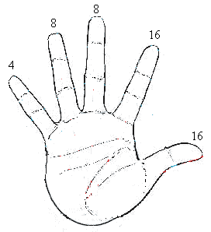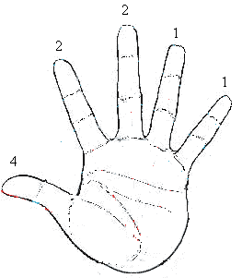
(note: palms are facing you – therefore the R. hand is the left picture, and the L. hand is the right)
Assign the number of points for each finger that has a whorl and substitute into the equation:
16 8 4 2 1
right right left left left
index ring thumb middle little + 1 =

right right right left left
thumb middle little index ring +1 =
16 8 4 2 1
That number is your primary classification number
Example: Suspect Sam the Serial Killer has whorl prints on R. index, L. index, and L. thumb
16 + 4 + 1 = 21 21/3 = Primary Classification # is 7
2 +1 = 3

