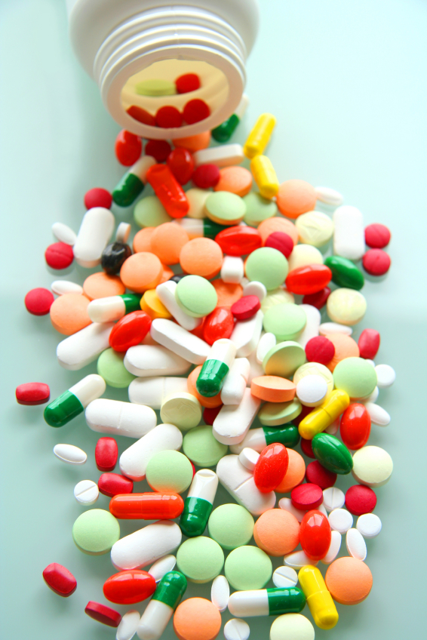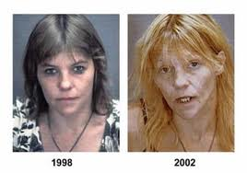
Unit 5 Outline and Objectives
Drugs and Toxicology (Efird’s Fave!)

Knowledge:
- Define toxicology and describe the functions of a forensic toxicologist.
- Explain the three ways a person can be exposed to toxic substances.
- Compare the term toxic substance and poison.
- Compare physiological and psychological effects caused by toxic substances.
- Compare physical and psychological dependences.
- What are the 5 main categories of drugs and describe:
  - Role the drugs plays on your body
  - Examples
  - Any physical or psychological effects?
- What is the DEA and describe the 5 drug schedules.
- How is chemical analysis used to identify drugs? Discuss the theory of chromatography and how it’s used in a forensic lab.
- Compare and contrast the five color tests used for drug identification.
- Discuss the microcrystalline test.
- What is instrumental analysis and compare spectrophotometry with mass spectrometry.
- Compare screening testing/presumptive testing and confirmatory testing.
- Discuss some common poisons and their effects on the body.
Skills:
- Be able to identify illegal substances and communicate the harmful effects caused on the human body systems.
- Use several chemical tests to determine an unknown substance.

Case Studies: Make sure you mention the drug/poison that was used.
*Nannie Doss (1900’s) *Tylenol Murders (’82)
*Jonestown Tragedy (’78) *Alexander Litvinenko
*Marie Besnard (Black Widow of Loudun) *Donald Harvey (the angel of death)

Celebrity Deaths (Will be done together): Heath Ledger, Michael Jackson, Elvis Presley, Anna Nicole Smith, Whitney Houston, Cory Monteith, Jimi Hendrix, Jim Morrison

Online Assignments: Found on weebly, submit to schoology. 4 Total: 1. Overdose or Poison; 2. Abused Drugs; 3. Drug Info Sheet; 4. Legalize-Yay or Nay

Unit 5 Outline and Objectives
Drugs and Toxicology (Efird’s Fave!)

Knowledge:
- Define toxicology and describe the functions of a forensic toxicologist.
- Explain the three ways a person can be exposed to toxic substances.
- Compare the term toxic substance and poison.
- Compare physiological and psychological effects caused by toxic substances.
- Compare physical and psychological dependences.
- What are the 5 main categories of drugs and describe:
  - Role the drugs plays on your body
  - Examples
  - Any physical or psychological effects?
- What is the DEA and describe the 5 drug schedules.
- How is chemical analysis used to identify drugs? Discuss the theory of chromatography and how it’s used in a forensic lab.
- Compare and contrast the five color tests used for drug identification.
- Discuss the microcrystalline test.
- What is instrumental analysis and compare spectrophotometry with mass spectrometry.
- Compare screening testing/presumptive testing and confirmatory testing.
- Discuss some common poisons and their effects on the body.
Skills:
- Be able to identify illegal substances and communicate the harmful effects caused on the human body systems.
- Use several chemical tests to determine an unknown substance.

Case Studies: Make sure you mention the drug/poison that was used.
*Nannie Doss (1900’s) *Tylenol Murders (’82)
*Jonestown Tragedy (’78) *Alexander Litvinenko
*Marie Besnard (Black Widow of Loudun) *Donald Harvey (the angel of death)

Celebrity Deaths (Will be done together): Heath Ledger, Michael Jackson, Elvis Presley, Anna Nicole Smith, Whitney Houston, Cory Monteith, Jimi Hendrix, Jim Morrison

Online Assignments: Found on weebly, submit to schoology. 4 Total: 1. Overdose or Poison; 2. Abused Drugs; 3. Drug Info Sheet; 4. Legalize-Yay or Nay

