Unit 2 Learning Objectives: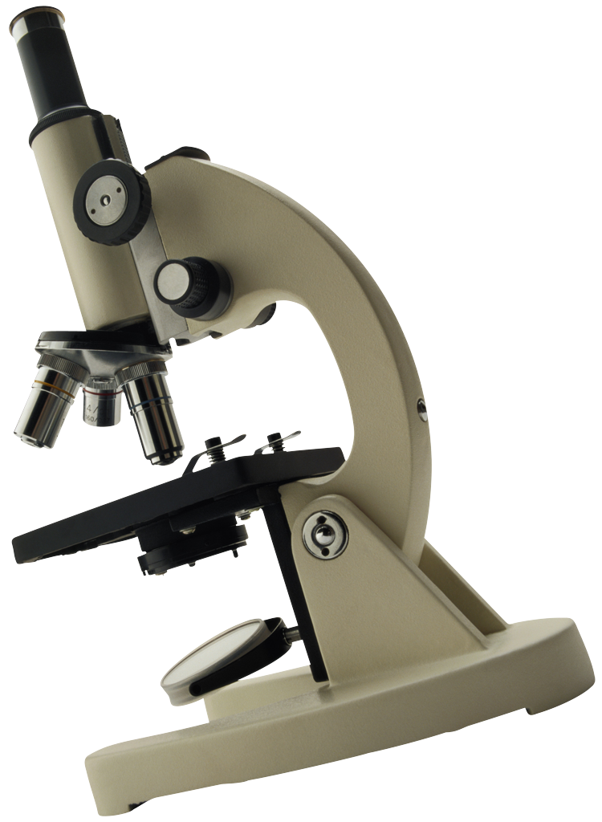
Crime Scene Investigation & Evidence

I. Unit Objectives: (15%) Grade:________________
1. Distinguish between the different types of evidence: Direct and circumstantial. Distinguish between characteristics evidence can possess: class and individual characteristics…provide examples of each.
2. Understand the concept of “chain of custody” & its importance.
3. Summarize the 7 S’s of crime scene investigation
4. Discuss the responsibilities of the first responding officer who arrives on the
scene. (in the 7 S’s)
5. Explain the 3 things needed to be done in order to thoroughly record (document) the crime scene.
6. Describe several procedures for conducting a systematic search (patterns) of a crime scene for physical evidence.
7. State some general packing rules for collecting evidence.
8. What is and what is the purpose of a reference/control sample.
Skills:
1. Identify evidence as either individual or class evidence
2. Process a mock crime scene and be able to:
Secure a crime scene , Search a crime scene, Collect evidence and retain the “chain of evidence, ” Make a paper bindle, Draw a crime scene sketch, Photograph a Crime Scene

II and III. Case Studies and Schoology Assignments (65%) Grade:__________

*****MAKE SURE you include the significance of the “crime scene” and how it was handled when writing about these particular cases!
*Meredith Kercher 2007_____________
*Lizzie Borden 1892________________
*Elizabeth Short or The Black Dahlia-1947_____________ (8%)

The following CS’s need to be done using the Schoology activity posted:
*Individual or Class Characteristics?__________
*Evidence Project_____________
*JonBenet Ramsey CS and Activity_________
*OJ Simpson CS and Activity______________
*Lindbergh Kidnapping and Activity__________
*Sam Shepperd CS and Activity ____________ (40%)

**Team Crime Scene and Reconstruction: (17%) _________________

IV: Unit Test: (20%) Grade:________________

Unit 2 Learning Objectives:
Crime Scene Investigation & Evidence

I. Unit Objectives: (15%) Grade:________________
1. Distinguish between the different types of evidence: Direct and circumstantial. Distinguish between characteristics evidence can possess: class and individual characteristics…provide examples of each.
2. Understand the concept of “chain of custody” & its importance.
3. Summarize the 7 S’s of crime scene investigation
4. Discuss the responsibilities of the first responding officer who arrives on the
scene. (in the 7 S’s)
5. Explain the 3 things needed to be done in order to thoroughly record (document) the crime scene.
6. Describe several procedures for conducting a systematic search (patterns) of a crime scene for physical evidence.
7. State some general packing rules for collecting evidence.
8. What is and what is the purpose of a reference/control sample.
Skills:
1. Identify evidence as either individual or class evidence
2. Process a mock crime scene and be able to:
Secure a crime scene , Search a crime scene, Collect evidence and retain the “chain of evidence, ” Make a paper bindle, Draw a crime scene sketch, Photograph a Crime Scene

II and III. Case Studies and Schoology Assignments (65%) Grade:__________

*****MAKE SURE you include the significance of the “crime scene” and how it was handled when writing about these particular cases!
*Meredith Kercher 2007_____________
*Lizzie Borden 1892________________
*Elizabeth Short or The Black Dahlia-1947_____________ (8%)

The following CS’s need to be done using the Schoology activity posted:
*Individual or Class Characteristics?________________
*Evidence Project_____________
*JonBenet Ramsey CS and Activity_________
*OJ Simpson CS and Activity______________
*Lindbergh Kidnapping and Activity__________
*Sam Shepperd CS and Activity ____________ (40%)

**Team Crime Scene and Reconstruction: (17%) _________________

IV: Unit Test: (20%) Grade:________________

